CERISE-SEE proof of concept
Implementation guide and functional/technical specification

This document explains how the current proof of concept works, how its parts are connected, and which logic must be preserved if the system is rebuilt in a more robust IT setting.
The document explains the role of the DPP, how activities and flows are interpreted, how the Functional Unit is handled, how links to BONSAI are created, how Brightway2 is used for the calculation, and how results are produced.
This document is written for internal colleagues who need to understand how the system works, even if they are not familiar with software-specific terminology.

Contents
1. System purpose and scope
2. Main parts of the system
3. DPP role and boundaries
4. Data model and JSON structure
5. How activities and flows are interpreted
6. Functional Unit and requested output
7. BONSAI and background linking
8. Multi-DPP linking
9. What is sent to Brightway2
11. Practical notes for handover
12. Glossary

1. System purpose and scope
The current proof of concept shows how structured product information can be stored in a DPP-like JSON file and then used for LCA calculation through Brightway2, with BONSAI as the intended background source.
The main idea is simple: first, the DPP stores the primary data provided by the actor. Then the CE-RISE side adds the study demand. Next, the system connects missing background inputs to BONSAI, transforms the DPP information into a Brightway model, and lets Brightway perform the calculation. Finally, the system returns the results.
The DPP is not the full LCA model. The DPP does not define the study demand, it does not define the Functional Unit as an active calculation input, it does not define the LCIA method to be used in a specific run, and it does not contain the calculation result. These elements are added later, on the CE-RISE side, when a specific study is run.
This separation is important because it allows the same DPP to be reused in different study situations.

2. Main parts of the system
The proof of concept is easier to understand if it is divided into separate parts, each with its own role.

2.1 Overview
Part of the system | Main role | Input | Output
DPP information layer | Stores the primary data in structured form | DPP JSON | Structured DPP ready to be read
Interpretation layer | Reads activities, flows, and determining flows | DPP JSON | Structured information ready for calculation
Study-definition layer | Adds the study demand | Functional Unit and requested output | Amounts to be calculated
Linking layer | Connects secondary flows to BONSAI or another DPP | Interpreted flows plus metadata | Resolved providers or blocking errors
Background layer | Makes BONSAI available to the system | Brightway project + BONSAI files | Background database ready for use
Calculation layer | Builds the Brightway model and runs the calculation | Resolved activities plus demand | Impact results
Output layer | Formats the results | Brightway results | Tables, totals, and exports

2.2 How these parts connect
The system works step by step.
From DPP to interpretation, the system first reads the DPP and checks that the required information is present. This includes the activities, the flows, the flow objects, and the determining flow for each activity. If key information is missing, the process stops.
From interpretation to study definition, once the DPP is understood, the system adds the study demand: which activity output is being requested and how much of that output is needed.
From study definition to linking, the system checks whether the flows can be connected to real providers. Secondary flows must be linked to BONSAI or another DPP, while elementary flows must be linked to the biosphere database.
From linking to Brightway, once the providers are known, the system creates the calculation model. Each activity becomes a Brightway process and each flow becomes the correct type of Brightway exchange.
From Brightway to results, Brightway2 performs the LCA calculation and returns the impact results.

3. DPP role and boundaries
The DPP is a structured carrier of primary data.

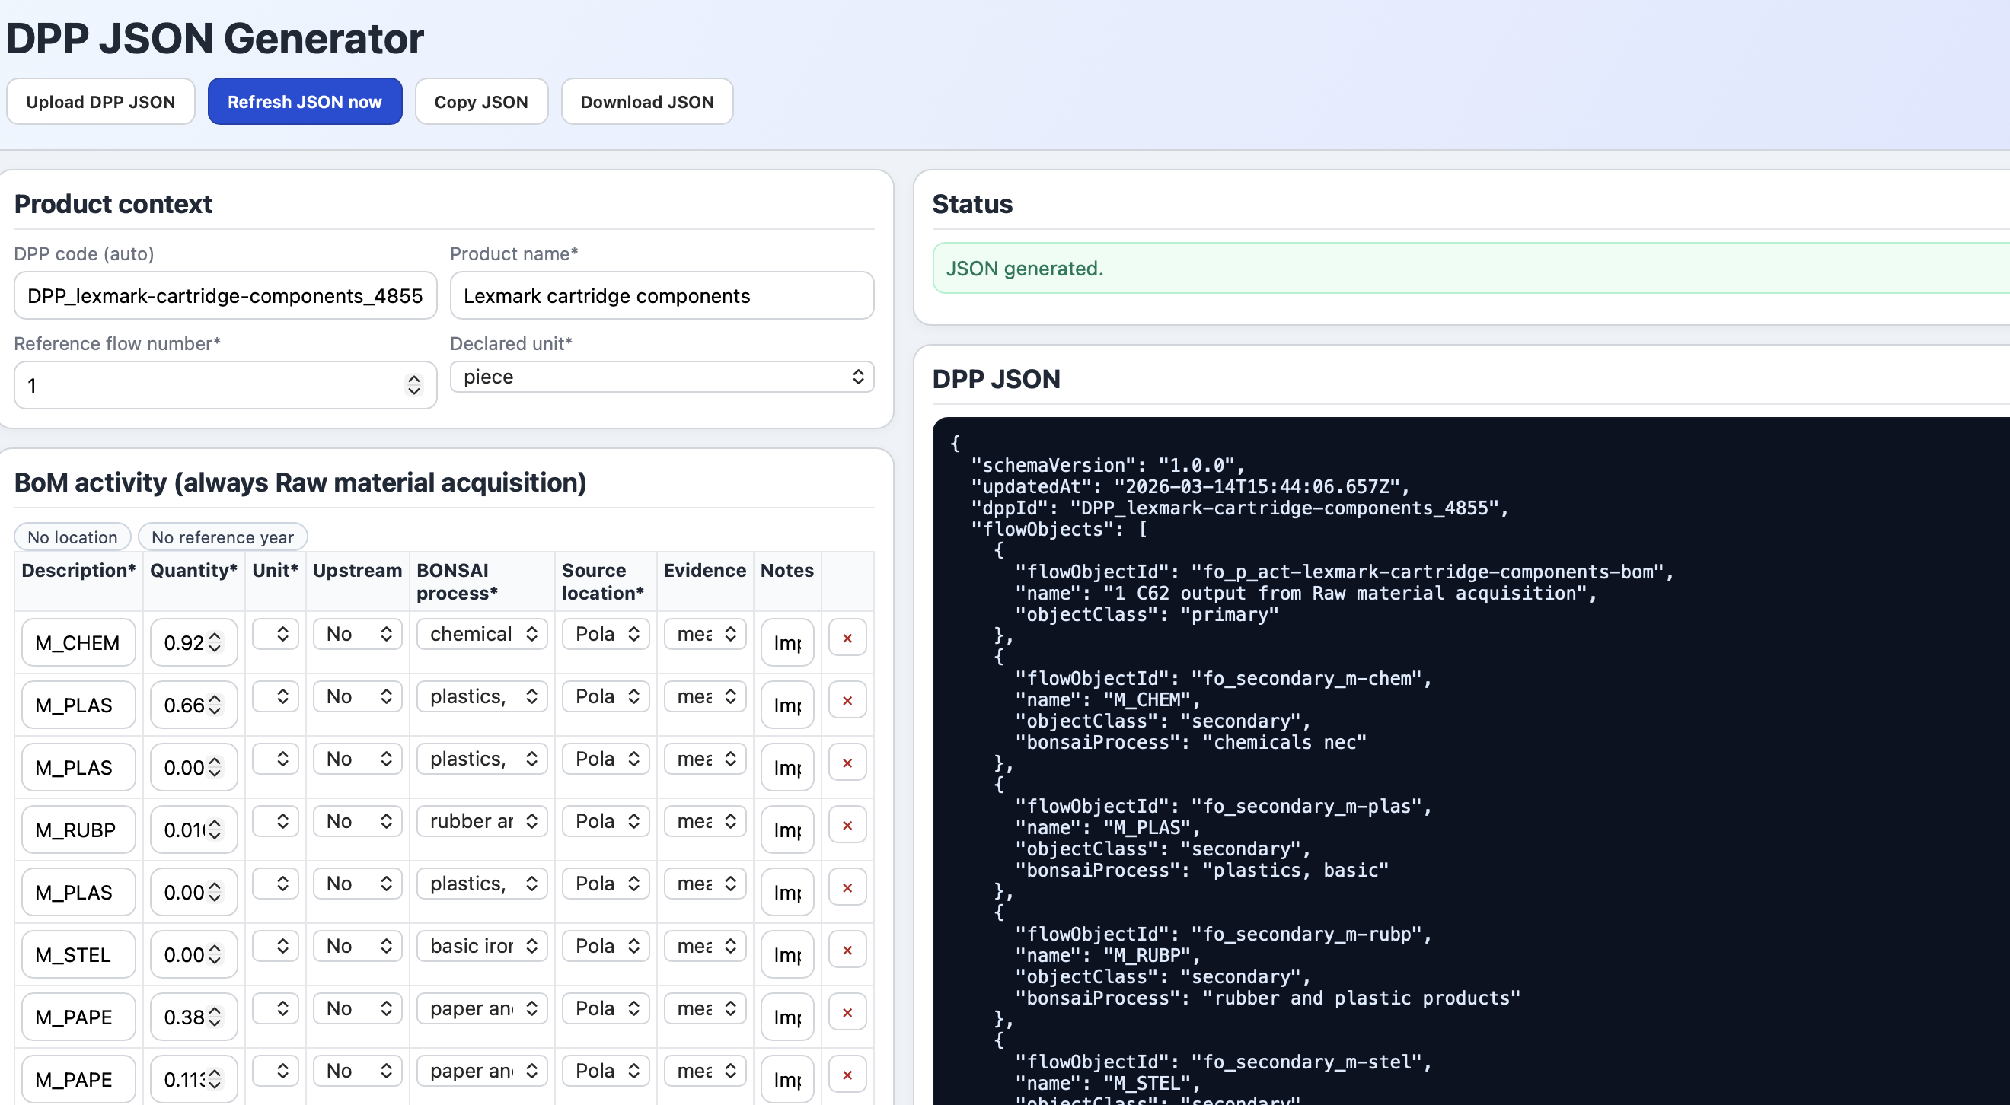
Figure 1, DPP JSON generator from dpp_live_form_minimal.py

In this proof of concept, the DPP contains the list of activities, the flows entering and leaving each activity, the flow objects referenced by those flows, the determining flow of each activity, and the metadata needed to interpret and resolve those flows.
The DPP therefore provides the foreground information of the system.

3.1 What the DPP must contain for the calculation to work
For the current main workflow, the DPP must contain at least:
- At the top level: dppId, flowObjects, and activities.
- For each activity: activityId, Activity, ActivityType, LCStage, flows, and determiningFlowId.
- For each flow: flowId, flowObjectId, direction, amount, and unit.
- For each flow object: flowObjectId and objectClass. The allowed flow object classes are primary, secondary, and elementary.
Some fields are required only in certain cases. Non-determining flows need evidenceMethod, and non-determining secondary flows need sourceLocation. For activities outside raw material acquisition, Place and ReferenceYear are required.

For the current strict operational workflow, secondary flows now require more explicit information than described above. Each non-determining secondary flow must carry bonsaiProcess, sourceLocation, and bonsaiCode. bonsaiCode is the exact BONSAI provider code selected at authoring time, in the form <TOKEN>|<LOCATION>, for example M_CHEM|PL. sourceLocation must match the location encoded in bonsaiCode. In the operational web runtime, DPPs that omit bonsaiCode on secondary flows are rejected.

4. Data model and JSON structure
The current proof of concept uses a practical JSON structure built around a DPP identifier, a list of flow objects, and a list of activities. Each activity contains its own flows and points to one determining flow.
A simple way to see the structure is: a DPP contains flowObjects and activities; each activity contains flows; and determiningFlowId points to one flow in the same activity.
Each flow contains a reference to a flow object, a direction, an amount, a unit, and optional metadata for linking or explanation.
In the current strict format, the BONSAI-routing metadata is no longer only descriptive or inferential. For secondary flows, the exact routing information is carried directly on the flow itself through bonsaiProcess, sourceLocation, and bonsaiCode.

4.1 Activity
An activity is one process-like unit in the DPP.
In the calculation, one activity is turned into one process entry in Brightway. For the current proof of concept, it is therefore safe to think of one activity as one process block that later becomes one Brightway process.
An activity includes an identifier, a name, a type, a life cycle stage, location and year where required, a list of flows, and one determining flow.

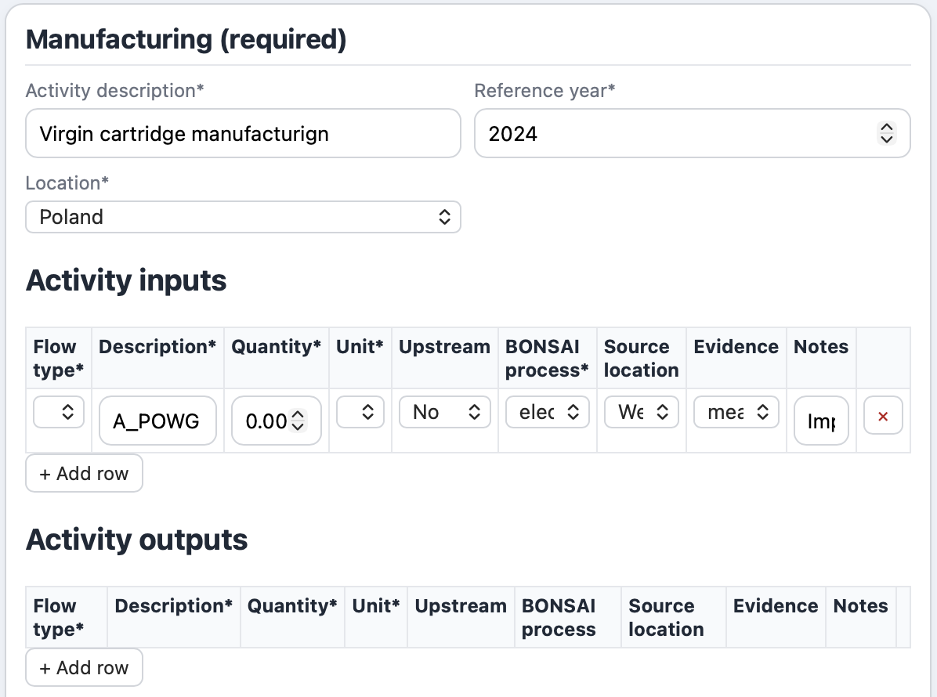
Figure 2, Manufacturing activity from DPP JSON generator from dpp_live_form_minimal.py

4.2 Flow object
A flow object defines what the exchanged thing is.
It is reusable. The same flow object can be referenced by several flows, including flows belonging to different activities.
So, a flow object is not the exchange itself, but it is intended as the definition of the exchanged item.

4.3 Flow
A flow is the activity-specific occurrence of a flow object.
It says which activity the exchange belongs to, whether it is input or output, how much of it is exchanged, in which unit, and which metadata is available for linking.
So the difference is simple: the flow object is the reusable definition of the exchanged thing, while the flow is one concrete exchange inside one activity.

4.4 Determining flow
Each activity has one determining flow.
The determining flow is an output flow linked to a primary flow object. It is the reference output of the activity.
It is the most important flow in the activity because it defines what that activity is producing. The determining flow is used to define the production exchange in Brightway, define the unit basis of the activity, and scale the activity when the user requests a certain amount of output.
The determining flow should represent the main intended output of the activity, not just any output.

5. How activities and flows are interpreted
The system reads each activity as something that will later become one Brightway process. The determining flow is the key to that interpretation.
First, the system reads one activity from the DPP. Then it reads determiningFlowId and finds the output flow that defines the activity’s reference output. After that, it looks at the other flows and classifies them using direction, flow object class, and whether they are determining or not.
In the current main workflow, the determining flow becomes a production exchange, a secondary input becomes a technosphere exchange, an elementary output becomes a biosphere exchange, and a secondary output becomes a technosphere exchange treated like a treatment output (waste incineration/end-of-life scenarios). Non-determining primary flows are not supported in the strict current workflow.

5.1 Example of this transformation
Suppose an activity has one determining output of 1 C62 and one secondary input of 0.02 KWH with bonsaiProcess = electricity by gas, sourceLocation = WE, and bonsaiCode = A_POWG|WE. The system reads the activity as one Brightway process, turns the determining output into the production exchange, validates that A_POWG|WE exists in BONSAI and matches both the declared process name and location, and then creates one technosphere exchange to that exact provider.
The system reads this as follows: one activity becomes one Brightway process, the determining output becomes the production exchange, the electricity input becomes a technosphere exchange, and the provider of that technosphere exchange is found in BONSAI.
So the final calculation object contains one process, one production exchange, and one technosphere input linked to BONSAI.

6. Functional Unit and requested output
The Functional Unit is not part of the DPP. This last one tells the system what data exists. The study side tells the system how much of it should be calculated. The calculation is provided in the Python code dpp_impact_calculator_online.py
To understand the calculation logic clearly, three things must be kept separate. The Functional Unit describes the study in conceptual terms: what is being assessed, how much function is required, how well it should perform, and how long it should last; the definition of the Functional Unit is a text string that has no calculation validity, but it serves as a reference for the LCA results in the documentation.
The requested output from an activity is the amount of the selected activity output that the user wants the system to calculate. This plays a key role since it is used by Brightway for the LCA calculation, in fact Brightway’s demand is the final input sent to Brightway for calculation; it is the executable form of the requested output.
In the current tool, the Functional Unit mainly describes the study. The actual calculation is driven by the selected activity, the selected activity’s determining flow, and the amount of that output requested by the study.


Figure 3, this is the part of the calculator in the section Functional Unit + Reference Flow, where the user defines how to rescale the whole product system, from dpp_impact_calculator_online.py

So, if your selected scope is BoM and Manufacturing and the factor is 4, the logic is effectively:
- calculate 4 x BoM
- calculate 4 x Manufacturing
- total = those two scores added together

6.1 Example
Suppose the selected activity has a determining flow of 1 C62 and the study asks for 3 C62.
The scaling is 3 divided by 1, so the result is 3. Brightway therefore receives demand equal to 3 units of that activity.
That is why the determining flow matters so much: it is the basis used to convert the study request into the actual calculation amount.

6.2 Two ways the current system can define demand
The current proof of concept supports two main approaches. In single-activity mode, the user selects one activity and requests a certain amount of its determining output. In per-activity mode, the user gives requested amounts for several activities separately. In both cases, the same rule applies: the requested amount is compared to the determining-flow amount of the activity.

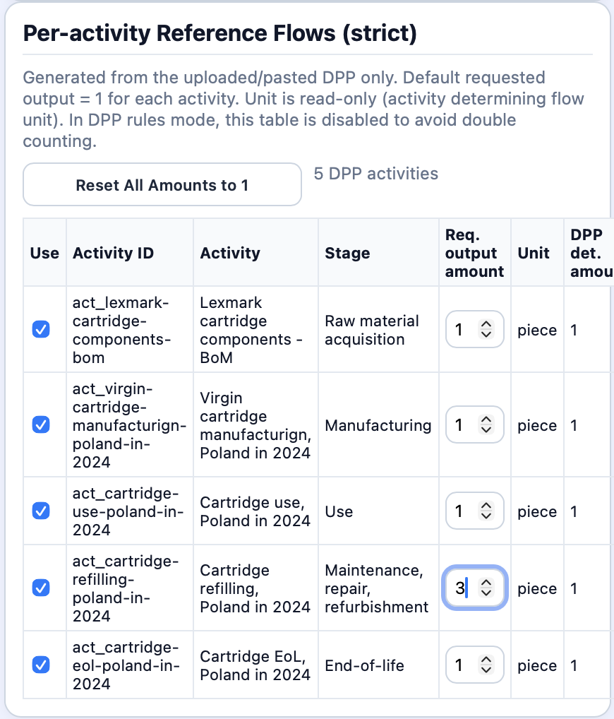
Figure 4, this is the Per-activity Reference Flows with the example of 3 refilling cycles Activity of a hypothetical ink printer cartridge, from dpp_impact_calculator_online.py

7. BONSAI and background linking
BONSAI is the intended background source in the current proof of concept.
In the current workflow, the main BONSAI candidates are secondary flows. This includes both secondary inputs and secondary outputs. Elementary flows are not linked to BONSAI; they are linked to the biosphere database instead.
The current workflow uses mainly sourceLocation, bonsaiProcess or classification, and flowObject.name.

7.1 Matching order in simple terms
The BONSAI matching logic can be explained step by step.
- First, the system checks that the source location is valid.
- Second, if a BONSAI process description is present, it searches BONSAI using that description and the location.
- Third, if exactly one match is found, it uses it.
- Fourth, if several matches are found, it prefers a unique market code such as M_... when possible.
- Fifth, if ambiguity remains, it stops and returns an error.
- Sixth, if description-based matching does not work, it tries using flowObject.name as a token or direct code hint.
- Finally, if no acceptable match is found, the system stops and returns an error.
The important point is that the current proof of concept is strict: it does not silently guess when the match is unclear.

7.2 Secondary outputs are not elementary flows
This is a very important point. Not every output is an environmental emission.
A secondary output that represents a treatment or recycling process must stay secondary and must be linked to BONSAI, not to the biosphere database.
If it is wrongly marked as elementary, the system will try to treat it as an environmental flow and the resolution will fail.

8. Multi-DPP linking
This section is included for completeness, but it does not describe the main current web-based calculation path.
The current main workflow does not actively use multi-DPP linking. However, the codebase does contain a second path in which one DPP can supply another.
The idea is that a secondary flow in one DPP may be supplied by an activity in another DPP when the flowObjectId matches the determining-flow object of the provider activity.
So this part should be understood as real code that exists, but it is backend-oriented and not the main active web-based workflow.

9. What is sent to Brightway2
Brightway2 is used only after the system has already interpreted the DPP and resolved the providers. This means Brightway does not decide what the determining flow is, which provider matches BONSAI, or whether a flow is secondary or elementary. All of that has already been decided before Brightway is called.
Before Brightway runs, the system already has the selected activities, the exchange type of each flow, the provider of each resolved flow, and the calculation amount to be used.

9.1 Example
A pre-Brightway object can be understood like this: one activity becomes one Brightway process with a name, a reference product, a unit, a location, and a list of exchanges.
For example, the process may contain one production exchange from the determining flow, one technosphere exchange linked to BONSAI, and one biosphere exchange linked to the biosphere database. The demand sent to Brightway may simply be this activity with amount equal to 3.

9.2 What Brightway still does
Once the system has prepared all of this, Brightway performs the inventory calculation, the impact calculation, and the final score calculation. So Brightway is the calculation engine, not the interpreter of the DPP.

12. Glossary
Term | Meaning
DPP | Structured file that stores the primary activity and flow data used by the proof of concept.
Activity | One process-like unit in the DPP. In the calculation, one activity becomes one Brightway process.
Flow object | Reusable definition of the exchanged thing.
Flow | Concrete exchange inside one activity, with direction, amount, unit, and optional linking metadata.
Determining flow | Main output of the activity. It defines the activity’s reference output and is used for scaling.
Functional Unit | Study-side description of what is being assessed.
Requested output | The amount of a selected activity output that the calculation should satisfy.
BONSAI | Background database used to supply secondary flows.
Foreground | The set of activities explicitly described in the DPP and handled directly by the system.
Background | External datasets used when the DPP does not contain enough information by itself.
Biosphere flow | A true environmental flow, such as an emission or resource flow, resolved against the biosphere database.
Technosphere flow | A flow linked to another product-system provider, such as BONSAI or another activity.

